NNCSS Membership Information
When you join the Northern Nevada Council for the Social Studies, you also join the National Council for the Social Studies, an organization of over 25,000 members.
An application for NNCSS membership can be downloaded from the council’s web site at http://www.nevadasocialstudies.org

NNCSS Organization Information
If you have questions regarding the Northern Nevada Council for the Social Studies, please contact:
Shyle Irigoin
sirigoin@washoe.k12.nv.us
Sue Davis
shdavis@washoe.k12.nv.us
Dr. Kathryn Obenchain
kmo@unr.edu
or see the Northern Nevada Council for Social Studies website at: http://www.nevadasocialstudies.org


The Northern Nevada Council for the Social Studies is an affiliate group under the National Council for the Social Studies. For more information regarding the national organization, please visit http://www.ncss.org

Northern nevada council for The social studies

Supporting educators in bringing high quality Social Studies to all of Northern Nevada’s students

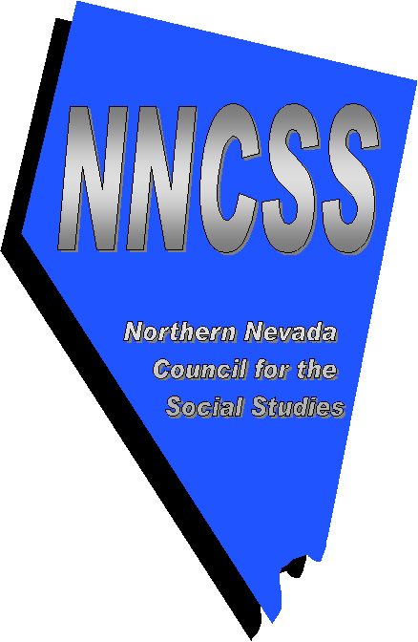
Chapter Information

What is the NNCSS?
The Northern Nevada Council for the Social Studies is an affiliated organization of the National Council for the Social Studies, the largest association in the United States dedicated solely to advancing social sciences education.
The NNCSS represents educators from kindergarten to college who are involved in all fields of social studies, including:
- History
- Geography
- Economics
- Political Science
- Sociology
- Anthropology
- Psychology
- Law-related fields

PUrpose of the NNCSS
The mission of NNCSS is to provide leadership, service, and support for all social studies educators in Northern Nevada. This is accomplished through collaborative activities year-round that allows for collegial support as well as expert assistance. The NNCSS also has an advocacy role in supporting social studies curriculum standards across Northern Nevada. As a source for news and issues affecting the field of social studies, NNCSS is a vital resource that provides timely, pertinent information to its members.
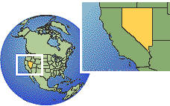
NNCSS not only focuses on Northern Nevada issues but gives its members a global view of Social Studies

Membership Benefits
When you join the NNCSS you are eligible to receive a number of valuable benefits. A small sample of these rewards are:
- Well respected publications, journals and newsletters that address current issues in social studies as well as provide a wealth of curriculum information and ideas
- A professional organization that will work to support social studies as a valued component of school curriculum, with resources to advocate at the state level
- A collaborative effort among social studies professionals in improving education and strengthening student growth and interest in the field
- Financial incentives such as insurance discounts and credit card opportunities
- Discounts on NCSS materials for educators
- Conferences and workshops held throughout the year that provide professional development for social science educators at all academic levels
For a more thorough listing of member benefits, go to the on-line index at http://www.socialstudies.org/membership

Teaching resources
No matter what field of social studies you teach, the NNCSS is able to provide in-depth and thought-provoking resources for use in the classroom. Information on state standards and resources, curriculum-based lesson plans, and links to additional free educational materials are all available to member educators.
Grants such as the Fund for the Advancement of Social Studies Education provide recipients $10,000 in designing and improving social studies education and citizenship training for students.

